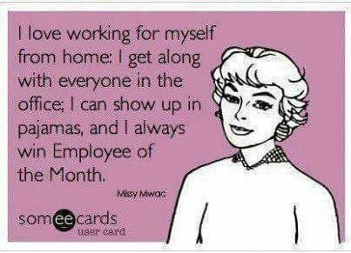

**Working in pyjamas?**

A Facebook friend shared this the other day and it got me thinking about my own habits. There’s a common perception that people who work at home don’t always bother getting dressed but it certainly isn’t true for me.

The beauty of being a freelancer is that you can mostly choose who you work with and how you get the job done. If that means sitting in bed with your pyjamas on and a laptop on your knee then go for it. Of course, it’s easy to forget that being a freelancer doesn’t always mean working at home. I’d be interested to see the reaction if a project manager turned up to chair a meeting wearing only a onesie and slippers!

If your work involves anything that can be accomplished with the use of a laptop or phone, you could be anywhere with a decent mobile or Wi-Fi signal and your client will be none the wiser. I’m at the desk in my living room with my back turned to the kids’ toys. (I could still type on the sofa but my physio would tell me off).

For me, where I choose to work and what I wear is part of getting myself into the right frame of mind. Back in the days when I worked in an office I did the same things that everyone else does; get up, brush my teeth and put on office appropriate clothes before heading off to the train. They are simple steps which become automatic over time but which also create a mental transition between home and office. That’s much more challenging when, in theory, all I have to do is walk downstairs and turn on the laptop.

The beauty of working at home is that whilst the transition may be less dramatic in terms of location, it is entirely up to me how I create it. I’m lucky in that I have two small children that need to be taken elsewhere before I can get anything done. The walk back from school is often the time that I have my best ideas, or a breakthrough if there’s a problem I’ve been pondering.

Even though my desk is at home, I’ve still found myself adopting some of the habits that I developed working in an office. Reading emails and reviewing my diary over the first cup of tea helps me to start the day feeling organised.

Dressing in a professional way has also become very important to me. I might be pursuing a creative career but it’s still a business. I’m asking people to part with their hard earned money to use my services and they’re mostly sole traders and small business owners like me. I’m putting myself forward as the solution to my prospective clients’ communication issues so I don’t want to be the cause of more stress. I think that the least they should expect is that I be professional and reliable. The way that I dress helps to remind me of that and keep me focussed. I might not be suited and booted (I was relieved to leave that behind), but I’m also not wearing the scruffy jeans that tend to come out when I’m off duty.

I’d love to know what you think. If you’re a client, what do you expect from your freelancer? If you work from home, do you have a routine and how did you develop it?