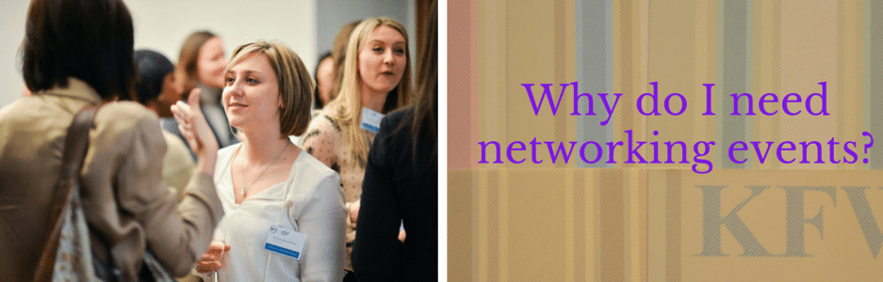
I’d been to networking events before, as a solicitor working for a big firm. Half the time I ended up talking to my own colleagues so the prospect of going to a networking event to sell my own business was understandably a bit daunting. Thankfully, Creative Coffee turned out to be my kind of event.

I’m lucky to live within striking distance of Leicester, which has always been good at theatre but which has dramatically improved its’ cultural and creative offering since the Curve Theatre opened in 2008. Creative Coffee came about as a way to encourage growth in the sector so I was keen to find out more. The events are held fortnightly and alternate between the Phoenix (a local independent cinema) and LCB depot, a former bus depot (the clue’s in the name) which has been converted to provide office and studio space for creative businesses.

I’m very familiar with the Phoenix; any cinema that sells wine and lets you take it into the screening with you is onto a winner with me! I hadn’t been to the LCB depot before but it was easy to find and I found myself being served with my tea alongside the organiser and another first time attendee. I confess that I’d had visions of lots of newbies standing nervously around the edges of a room whilst all the people who already knew each other chatted in the middle. It wasn’t like that at all. We all sat around a long table and swapped seats occasionally to meet new people. Of course, that lead to plenty of jokes about speed dating, but the less said about that the better. At least it broke the ice.

What struck me most was the range of expertise on display around the table. There were several writers, web designers, marketing specialists, a face painter and even a friendly solicitor. I hadn’t expected to be networking with one of those so soon after leaving the law. There was a financial advisor who was also a self-described techie. He was a Leicester Tigers rugby fan, which demonstrates the calibre of person attending these things.

I realise now that I hadn’t always appreciated the value of networking. In my legal practice, whilst I understood that there were some services which could be offered direct to businesses, my own area was very much insurance based. Coming to Creative Coffee I realised that there is huge potential for collaboration. A web developer can build you a site but you’ll probably need a designer to make it look good and a writer to get your message across. It was exciting to realise that anyone coming along with a potential project could have put a team together from the people sitting around the table. They could even talk to someone who could provide them with a meeting room in the city centre.

If you’re nervous about coming along as a new freelancer, don’t be. I was greeted as a new friend. Or, if you have a creative project and need to find the right people to implement it, come along. As far as I can tell, no one bites.

